Advance Visualizations in Tableau

# Map

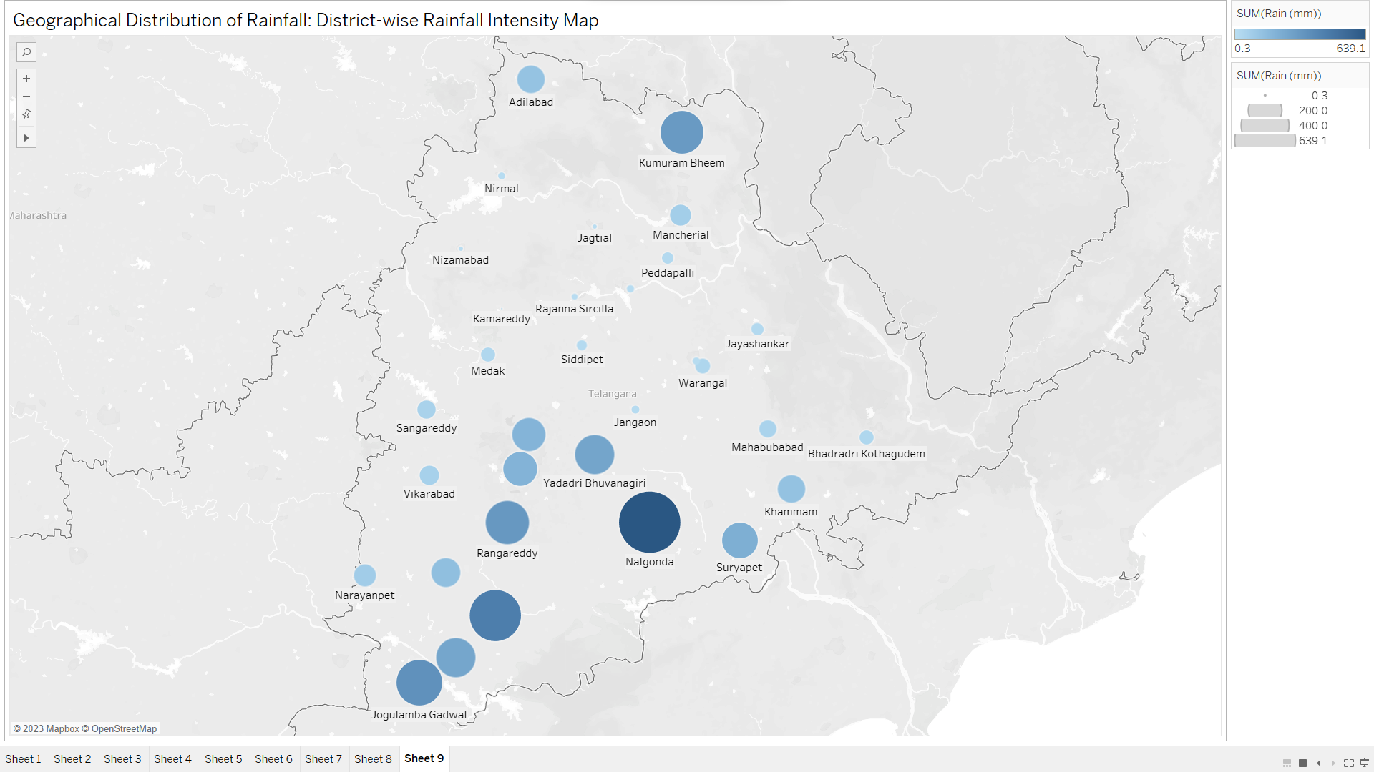

The Geographical Distribution of Rainfall presents a District-wise Rainfall Intensity Map, using color-coded gradients to depict varying precipitation levels across different regions. This visualization allows users to discern patterns and identify areas with high or low rainfall intensity, aiding in weather analysis and resource management.

# HeatMap

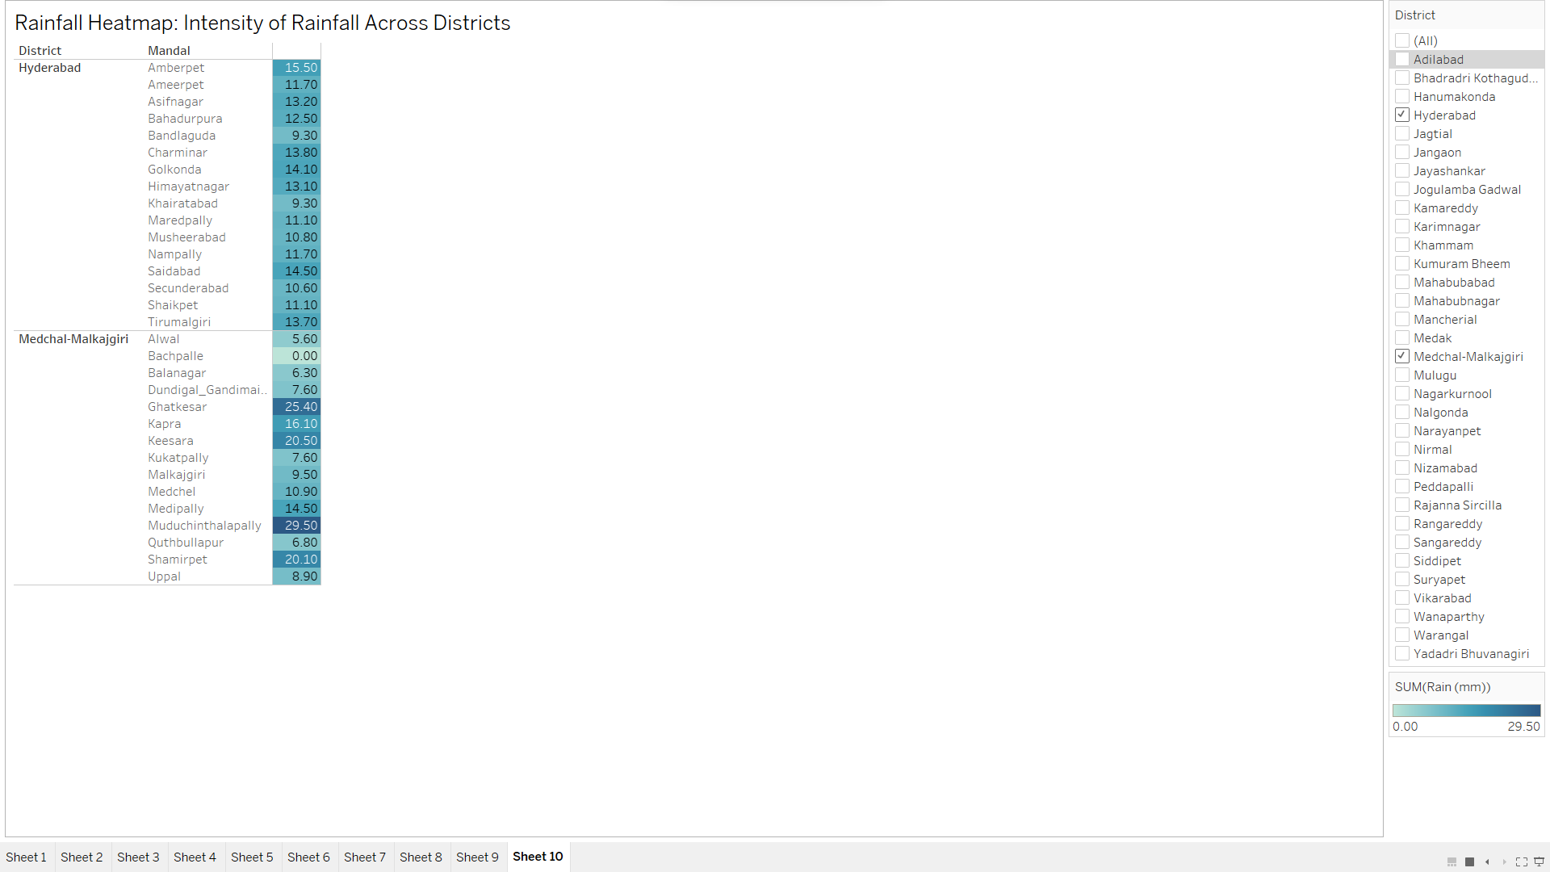

The Rainfall Heatmap illustrates the Intensity of Rainfall across selected Districts. Using color gradients to represent precipitation levels, this heatmap offers a concise and visually engaging view of rainfall variations, enabling users to identify areas with the highest and lowest rainfall intensity in the chosen districts.

# DashBoard

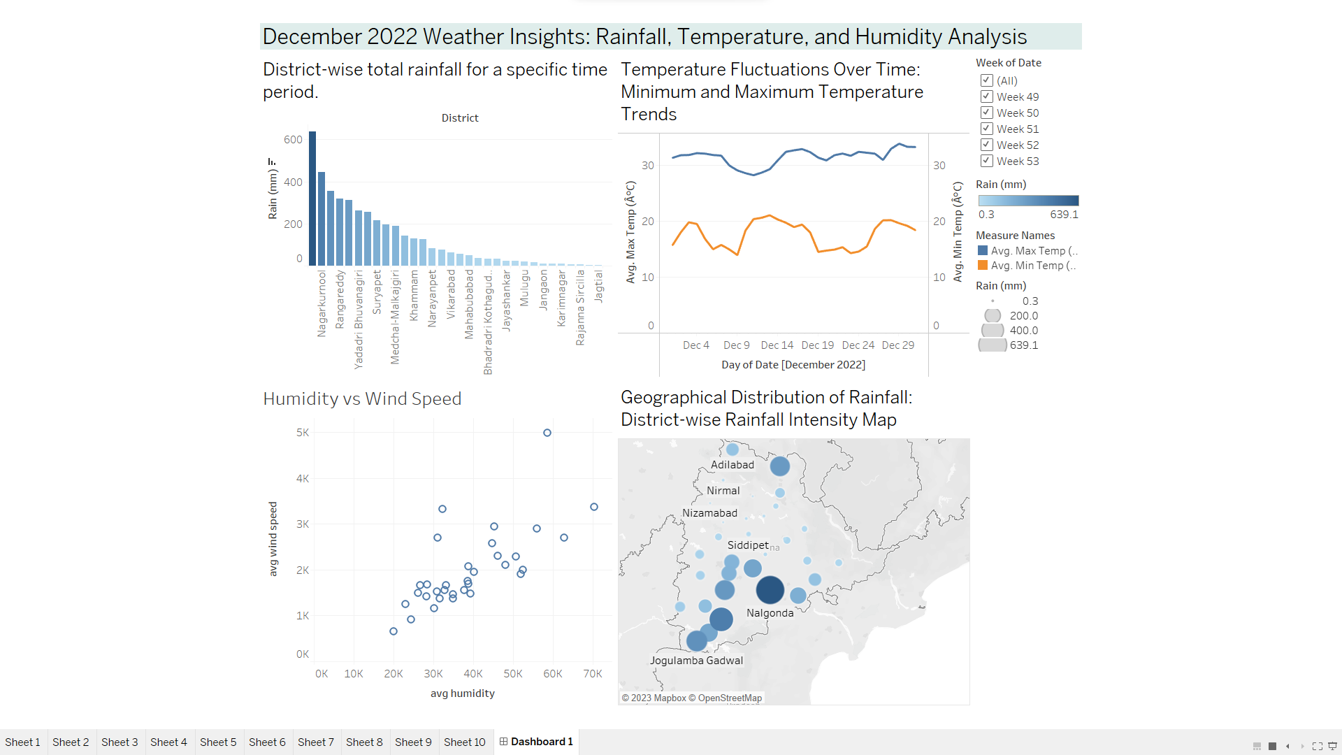

December Weather Insights provide a comprehensive analysis of rainfall, temperature, and humidity during the month. This visualization offers valuable data-driven insights into weather patterns, allowing users to explore the relationships between rainfall, temperature fluctuations, and humidity levels, aiding in understanding climatic variations for the selected period.